15. Create a script with one variable named badly (like X) and run pylint to see the warning. Rename it to follow lowercase_style and rerun pylint

- Pylint_basics_test.py
# Pylint basics test
X = 5

Pylint output
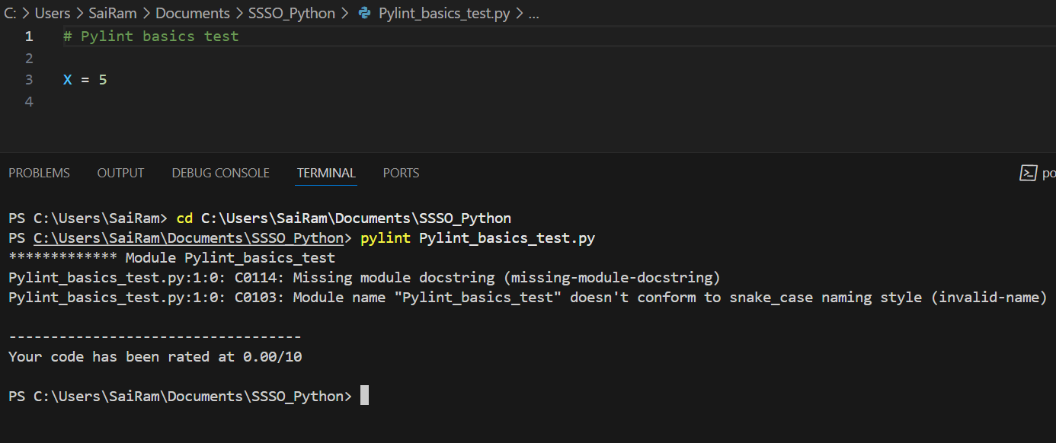

B. Rename file to follow naming convention pylint_basics_test.py
and add doc string and then re run pylint

# Pylint basics test
"""
create a variable x and assign a value
"""
X = 5

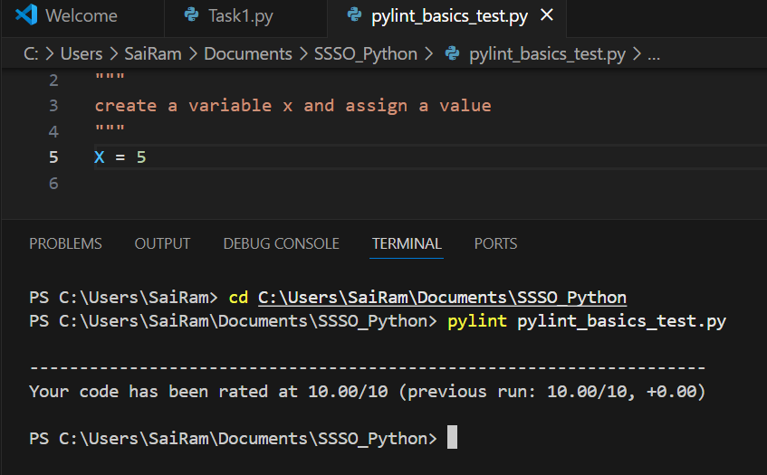
C. Change the variable naming convention and re run pylint
# Pylint basics test
"""
create a variable x and assign a value
"""
x = 5

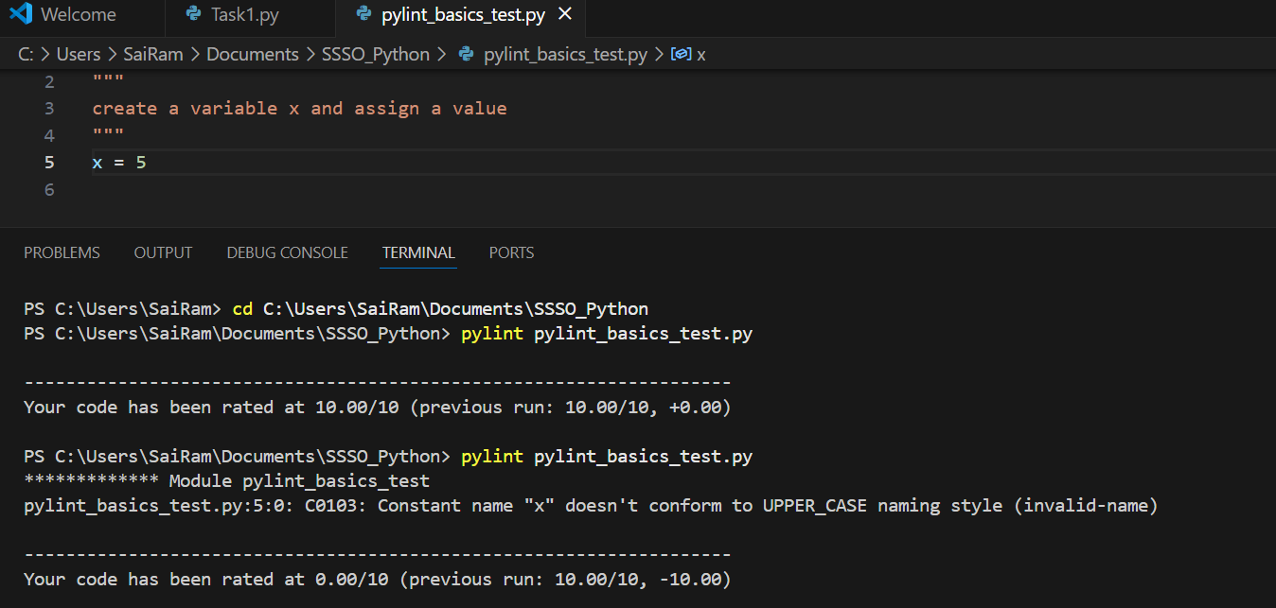

16. Use sys.argv to accept one word from the command line and print it back. (Run: python echo.py hello).
Step1 : Create a script to use sys.argv
# echo.py
"""
This is a sample script to read command line input
"""
import sys

# Check if the user provided a word
if len(sys.argv) < 2:
print("Enter input in the format:")
print("python echo.py <word>")
else:
word = sys.argv[1]
print("You entered:", word)

Step2 : Run the script in CLI
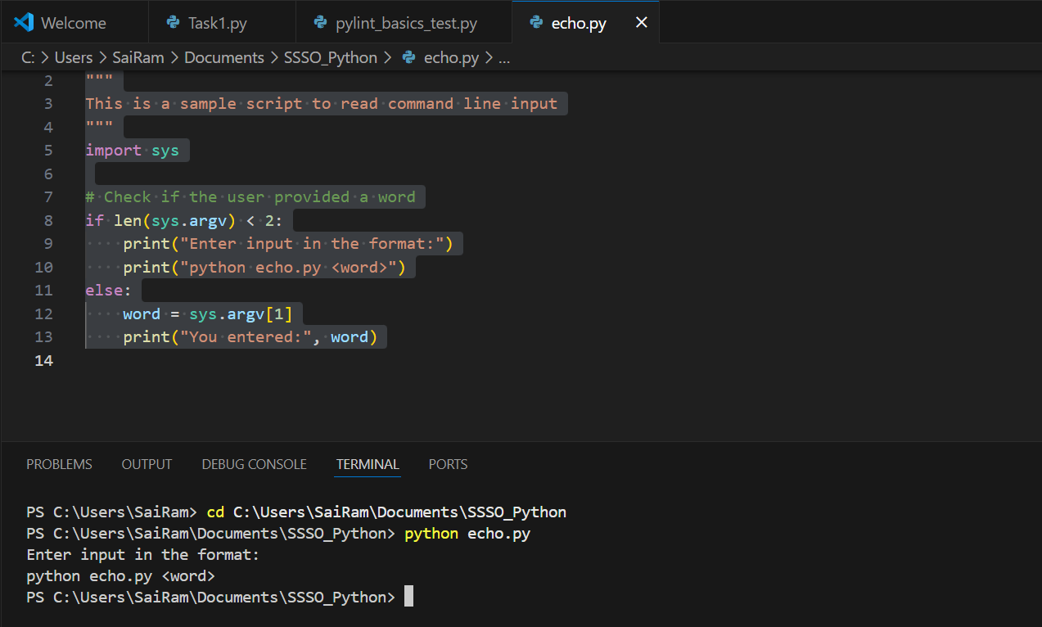
Step 3 Enter an input word in CLI while running the script
